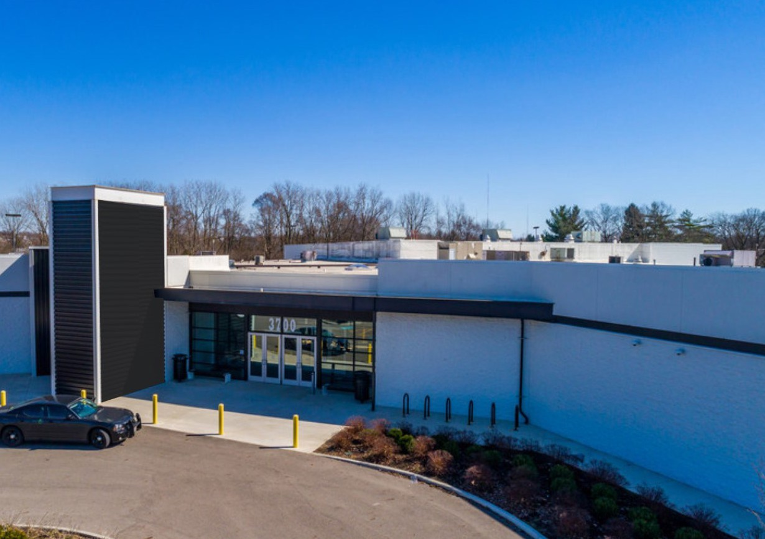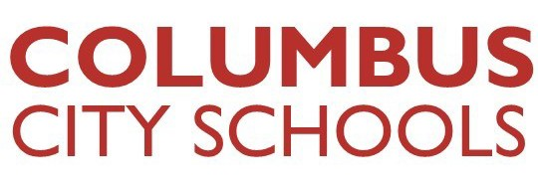

OFFICE OF **OUTREACH SERVICES**

A Guide To Doing Business With

**COLUMBUS** CITY SCHOOLS

**COLUMBUS** CITY SCHOOLS supports initiatives that are inclusive of the diversity within our communities while enhancing student success. Therefore, we actively seek

**Local Economically Disadvantaged Enterprises** (LEDEs) to participate in all contracting and procurement opportunities.

OVERVIEW

# Table of Contents

Message From The Board Of Education 1

Columbus City Schools… At A Glance 2 & 3

The Office of Outreach Services: How They Can Help You 4

LEDE Registration 5

The Procurement Process 6

Departmental Queries: Identify Which Departments Buy What You Sell 7

Final Notes 8

Most Frequently Asked Questions 9 &10

**COLUMBUS** CITY SCHOOLS is

proud to serve as a leader in our community and we are committed to being good neighbors. We believe that holding ourselves to the highest standards possible is an obligation that extends beyond our children and into the entire community. As we grow, we want the community to grow with us.

One way that we can accomplish this is by partnering with small local businesses.

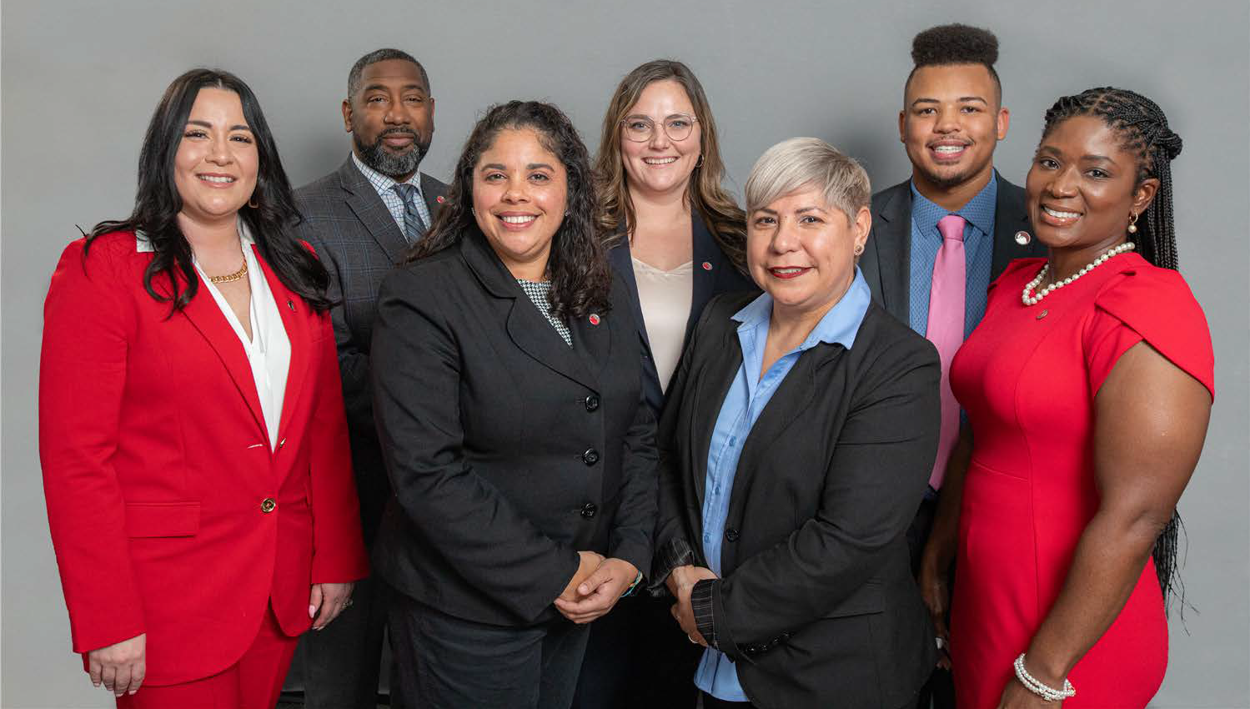

**BOARD OF EDUCATION** (left to right): Christina Vera (President), Michael Cole, Jennifer Adair, Sarah Ingles, Ramona Reyes, Brandon Simmons, and Dr. Tina Pierce (Vice President)

Our Community Inclusion Policy is an example of our commitment to the local small business community. Developing mutually beneficial relationships with local suppliers helps us ensure that local economically disadvantaged enterprise vendors build economic vitality in our community.

We have a 20% LEDE participation goal on an annual basis with our LEDE business community

to reflect the thousands of children we serve every year, as well as the community where Columbus City Schools has a presence. Our Community Inclusion Program is comprehensive in its approach and makes good business sense.

Columbus City Schools’ commitment to diversity and inclusion allows us to cast the widest net when seeking suppliers and professionals to support and complement the great work of our students.



We invite you to use this guide as a reference when seeking opportunities with our district.

Sincerely,

Columbus Board of Education

**COLUMBUS** CITY SCHOOLS

# We Appreciate Your Interest In Partnering

**With COLUMBUS** CITY SCHOOLS

Columbus City Schools, established in 1845, is the state of Ohio’s largest school district, serving the needs of more than 46,000 students in 115 schools.

Columbus City Schools also has a graduation rate of 85%, which is the highest in its State Report Card history. Columbus City Schools is putting into place initiatives to bolster support for schools needing to improve academic performance. The District will provide tiered assistance for schools in School Improvement Status, and bring on coaches (retired teachers) for in-classroom assistance and strategic planning support for schools.

**Mission Statement:**

Each student is highly educated,

prepared for leadership and service, and empowered for success as a citizen in a global community.

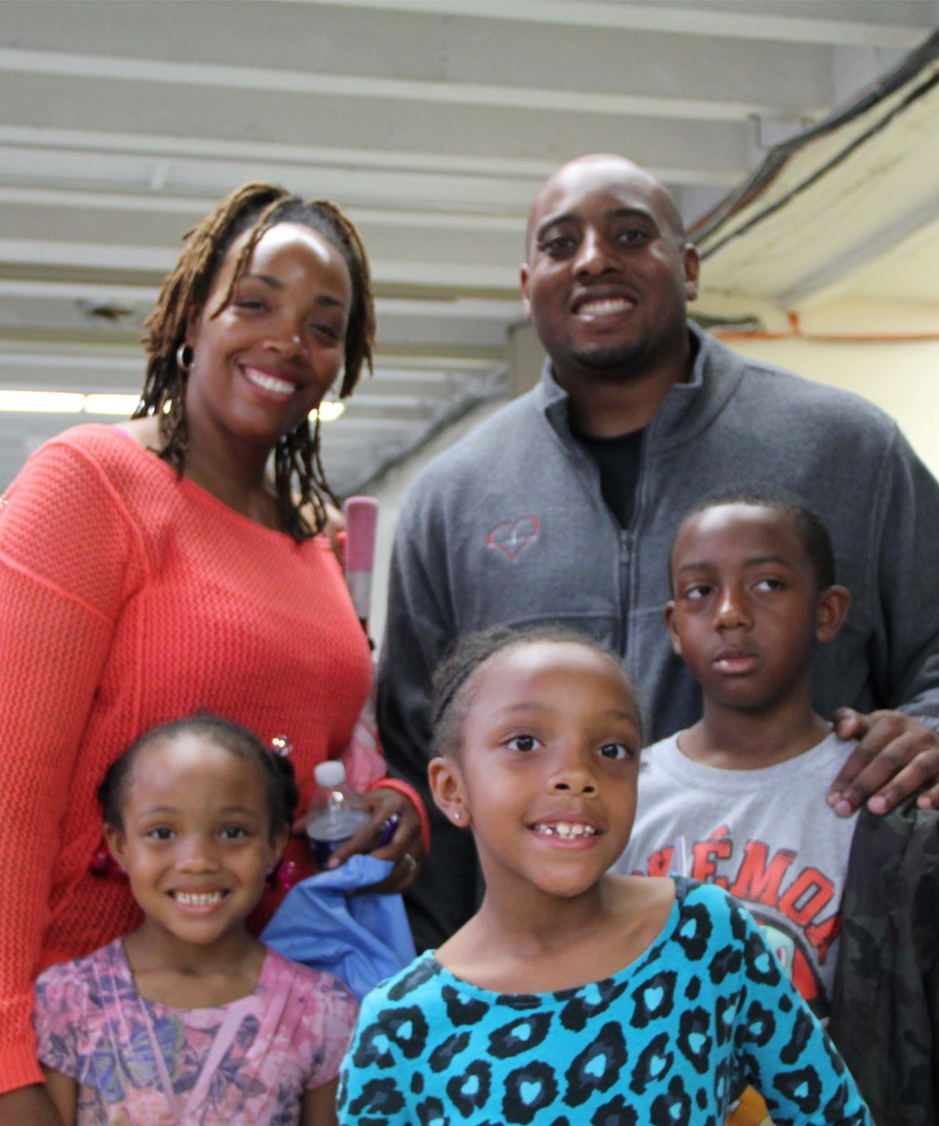

# District At-A-Glance…

* **COLUMBUS** CITY SCHOOLS is the largest school system in Ohio.
* The district covers an area of more than 142.9 square miles.
* The district operates 56 traditional Elementary schools, 18 traditional middle schools, and 18 traditional High Schools and Programs.
* There are 105 different spoken languages in the District with the most frequent being, Arabic, English, French Creole, Nepali, Somali, and Spanish.
* Student enrollment is approximately 46,000 students (as of May 2024)

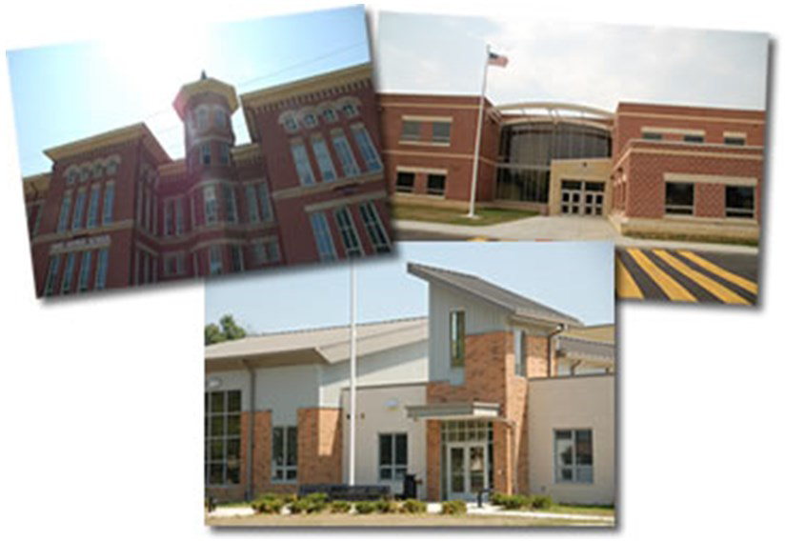

# The Office of Outreach Services:

**How They Can Help You**

**The Office of Outreach Services:**

* Recruits and provides services to potential vendors by means of the [Guide to doing business with CCS](https://www.ccsoh.us/cms/lib/OH01913306/Centricity/Domain/1706/LEDE%20OUTREACH%20Booklet%20REVISED%202024%20VERSION%20with%20BOARD%20UPDATE.pdf)
* Facilitates meetings with potential vendors and appropriate Columbus City Schools Staff to

discuss procurement and contracting opportunities with these various departments.

* Notifies LEDE businesses of bid opportunities.
* Certifies LEDE business entities by completing the [LEDE Certification Affidavit](https://www.ccsoh.us/domain/1706), and including supporting documentation.
* Assists prime contractors to ensure they are making  [Good Faith Efforts Guideline](https://www.ccsoh.us/domain/1706).



**Contact Information**

Outreach Services

3700 S. High Street Suite 143

Columbus, OH 43207

Office: 614-365-8869

Email:[outreachservices@columbus.k12.oh.us](mailto:outreachservices@columbus.k12.oh.us)

**Hours of Operation**

Monday – Friday: 8 a.m. – 4:30 p.m.

# LEDE Registration

The **Office of Outreach Services** works to provide the district with supplies, equipment, and services that help produce outstanding results.

Review the various functions on the following pages and determine where your business fits our needs. A critical first step is to register and complete a

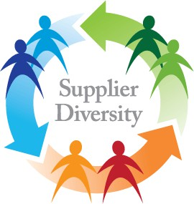

LEDE Vendor Affidavit. Your LEDE Affidavit will be confirmed and you will be contacted. Completing this document allows us to better understand

your business.

The LEDE Vendor Affidavit acknowledges that your firm meets the criterion for certification as outlined in the **Community Inclusion Policy 6450**. By completing the LEDE Vendor Affidavit, including all supporting documentation, you will be placed in our database as an LEDE business.

This database is updated monthly and will be made available to all internal district employees, as well as all external potential prime contractors as a tool to locate ready, willing, and able LEDEs to compete for contracting and procurement opportunities as prime contractors, subcontractors, and joint venture partners. [LEDE Vendor List](https://www.ccsoh.us/domain/1706)

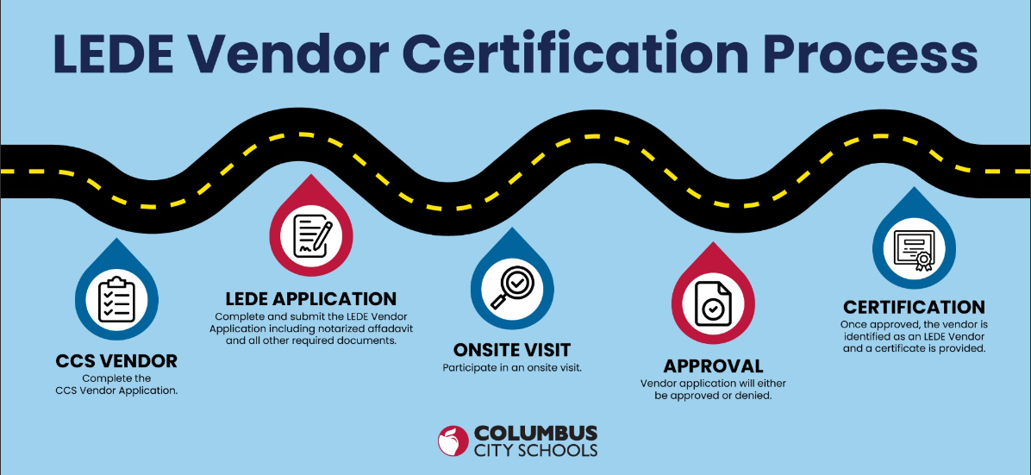

## To read the Community Inclusion Policy, go to:

[**po6400**](https://go.boarddocs.com/oh/columbus/Board.nsf/Public) **Community Inclusion (Local Economically Disadvantaged Enterprises)**

[**po6450**](https://go.boarddocs.com/oh/columbus/Board.nsf/Public) **Local Purchasing and Outreach**

# The Procurement Process

You will need to register as a vendor by going to [www.ccsoh.us/Vendors.aspx](http://www.ccsoh.us/Vendors.aspx) and click on Vendor Self Service Website / Registration, then complete a LEDE Vendor Affidavit (and provide supporting documentation). Once you register as a vendor you will get a vendor number. After your vendor record is reviewed and your supporting documentation is verified your company will become an active vendor in the Columbus City Schools vendor database. You can get the LEDE Vendor

Affidavit from Outreach Services [outreachservices@columbus.k12.oh.us](mailto:outreachservices@columbus.k12.oh.us) or go to [www.ccsoh.us/Vendors.aspx.](http://www.ccsoh.us/Vendors.aspx)

Most departments will require a quote to be submitted through Public Purchase, the bid software the district uses. Public Purchase decreases the probability for misunderstandings and benefits all parties involved. Be sure to prepare a quote that considers the needs of your business and Columbus City Schools. If you are in doubt, please contact the originator before submitting

your quote.

**Most acceptable quotes include:**

* *A description of the scope of work to be performed (or products to be sold) and other applicable specifications.*
* *Pricing and delivery schedule/time-frame.*
* *Payment terms*

The **Purchase Order** is Columbus City Schools reply to your quote award and serves as the “authorization” to begin work. Be sure to get a copy of the Purchase Order from the Purchasing Department (prior to beginning any work) and review to ensure that all terms and conditions match what was submitted in your quote. If the outlined information in the Purchase Order does not match what you submitted in your quote:

* Contact the Purchasing Department at [purchasing@columbus.k12.oh.us](mailto:purchasing@columbus.k12.oh.us) to review options for moving forward.
* Do not begin working without a copy of the Purchase Order. This is Columbus City Schools’ acknowledgement, contract and commitment for the work.

Upon completion of work (or at previously agreed upon intervals) you must submit an invoice in order to be paid. Be sure to reference the Purchase Order number on all invoices. Unless another arrangement has been made between you and the department, all invoices should be submitted directly to Accounts Payable.

**COLUMBUS** CITY SCHOOLS

Attn: Accounts Payable

270 E. State St.

Columbus, OH 43215

Phone: 614.365.6473

Fax: 614.365.5628

**Departmental Queries:**

# Identify Which Departments Buy What You Sell

**Columbus City Schools** is seeking businesses that can meet our contracting and procurement needs of quality, service and value. Below is a list of areas that you might consider as potential opportunities. While many of these areas have primary contracts and a few perform much of the

work in-house, we do contract with vendors to meet our service and overflow needs.



|  |  |
| --- | --- |
| **WHAT DO YOU SELL?** | **CORRESPONDING DEPARTMENT** |
| Architect & Engineering Services | Capital Improvements, 889 E. 17th Ave. |
| Building & Grounds | Buildings & Grounds Dept., 889 E. 17th Ave. |
| Custodial Services | Buildings & Grounds Dept., 889 E. 17th Ave. |
|  |  |
| Information Technology | MIS Department, 1091 King Ave. |
|  |  |
| Transportation Services | Transportation Dept., 1560 Moler Rd. |
| Media Relations & Communications | Media Relations & Communications, 270 E. State St. |
| Food Services | Food Services Production Center, 450 E. Fulton St. |
|  |  |
| Supplies | Purchasing, 889 E. 17th Ave. |
|  |  |
| Office Supplies | Purchasing, 889 E. 17th Ave. |
| Printing | Purchasing, 889 E. 17th Ave. |
|  |  |
| Audio Visual | Purchasing, 889 E. 17th Ave. |
|  |  |
| Safety & Security | 889 E. 17th Ave. |
|  |  |
| Athletics | 3201 Allegheny Ave. |
| Academic Achievement Support | 270 E State St. |

# Final Notes

**Value:** It is important to be clear, state your company’s advantages and what distinguishes you from your competition. Be prepared to communicate your added value**.**

**Be flexible and responsive:** Being a small business can often mean having the flexibility to customize solutions for your customers.

**Get Certified:** If you are a local, small disadvantaged business, certification is critical. This is a distinguishing aspect of doing business with Columbus City Schools. More information can be found at the District website for the LEDE Program, and other certifications would be helpful such as the State of Ohio’s EDGE Program, the SBA’s 8(a) Program, and the DEBE program under the Unified Certification Program.

**Consider partnering with large firms on large contracts:** At Columbus City Schools we seek prime contractors and suppliers. A prime contract is defined as a contract awarded directly to an organization or business. While many small firms do not have the capacity to serve as prime suppliers, there are often opportunities -through subcontracts, partnerships, or joint ventures.

Please contact Outreach Services; we are happy to assist you.



**Innovation:** Use a creative solution-based approach with potential departments that may help you stand out.

**Capacity:** Doing business with Columbus City Schools requires that your business be experienced, have the adequate capabilities and the ability to be flexible. Be certain your business can handle the project scope.

**Be Prepared:** This cannot be overstated. Remember, you are making a first impression. Be

certain that your marketing materials, Website, and presentations are professional and error free.

**Investigate:** Columbus City Schools’ employees are contacted frequently by vendors, so it’s important to demonstrate your knowledge and understanding of Columbus City Schools’ needs and environment, as well as your capacity and ability.